**Econ 206 Test 5 (Write your name on the scantron)**

1. We illustrated the “omitted variables bias” of regression analysis using

a. data for gender and pay at WKU

b. data for diamond prices and diamond size

c. data for the CPI and the price of oil

d. none of the above

2. The “omitted variables bias” in regression analysis is an example of broader statistical problem of not taking account of the influence of additional variables known as

a. the St. Petersburg Paradox b. Simpson’s Paradox

c. Gauss’ Paradox d. none of the above

3. In evaluating scientific evidence, we made use of the phrase from toxicology “the dose makes the poison.” The broader point of this phrase is that

a. the level of statistical significance chosen matters

b. the size of the sample matters

c. the size of the measured effect matters

d. the number of variables taken into account matters

4. The example of estimating the risk of auto v. air travel was used to emphasize

a. the problem of measurement error creeping into statistical studies

b. the importance of calculating percentage changes properly

c. the common problem of sampling error

d. none of the above

5. The warnings about “extrapolation” with data emphasize the problem of

a. including many additional variables that do not have a important influence

b. inferring results from sample data without regard for sampling error

c. extending the implications of data far beyond the range of the data

d. none of the above

6. We used the relationship between ACT and SAT scores to illustrate

a. the dangers of extrapolation

b. that crosstabulation is more accurate than regression

c. that correlation does not always mean causation

d. that non-sampling error can show up in very subtle ways

7. We discussed the case where regression analysis was used to examine the relationship between the return specific stock (rit), such as Microsoft, and the return on the market average (rmt). The example used showed rit = 0.08 + 1.3*rmt. In this example

a. the coefficient of 1.3 is an estimate of the risk of owning Microsoft stock

b. the coefficient 0.08 is known as the “beta” of Microsoft stock

c. Microsoft stock moves up and down less than the market average

d. none of the above

8. Suppose that the risk of an event was 1 in 1000 and then increased to 2 in 2000. This illustrates a

a. 100% increase in the risk b. 0.1 percentage point increase in the risk

b. a 1.0 percent increase in the risk d. no change in the risk

SPC X-Bar Control Chart for Hot Chocolate Temperature

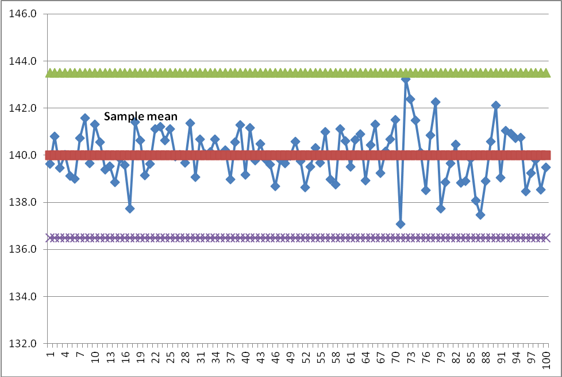

9. In the SPC control chart above,

a. the green and purple lines are based on +/- 3 standard deviations from the long run average

b. the red line is based on the short run sample averages

c. the blue dots illustrate the the process variation is not merely common or natural variation

d. all of the above

10. Control charts like the one above make use of the idea that

a. all processes/outcomes exhibit some built-in variability

b. high volume, repetitive processes/outcomes tend to have normally distributed outcomes

c. high volume, repetitive processes/outcomes don’t tend to show patterns or trends over time

d. all of the above

Exhibit 1: A random sample of 150 exam scores is collected from a population of 30,000 in exams given in the southeastern United States. The average exam score for the sample is 72 with a standard deviation of 12.

11. Based on the information in Exhibit 1, Mr. Davis states that the average exam score for the entire population is 72. This statement is an example of:

a. statistical inference

b. descriptive statistics

c. hypothesis testing

d. rational behavior

12. Based on the information in Exhibit 1, Ms. Wassom states that she is 95% certain that the average exam score for the population is somewhere in between 70.08 and 73.92. This statement is an example of:

a. descriptive statistics

b. the central limit theorem

c. a confidence interval

d. chebyshev’s theorem

Exhibit 2: The graph below represents the level of household income in the city of Bowling Green.



13. What type of figure is drawn in Exhibit 2?

a. a box plot

b. an ogive

c. a histogram

d. a scatterplot

14. Based on the drawing in Exhibit 2, what is the shape of income distribution?

a. nearly symmetric

b. skewed

c. uniform

d. unable to be determined

15. Suppose grades on the final exam in ECON 206 are highly skewed, which of the following measures will provide the best description of typical student performance on the exam?

a. the mean income

b. the mode income

c. the median income

d. the standard deviation of income

16. Consider a set of four scores on a ten-point quiz: 5, 7, 8, and 9. Suppose that a grading mistake was found, and the score of 9 was changed to a 10. As a result,

a. the standard deviation would increase

b. the standard deviation would decrease

c. the standard deviation would remain the same

d. the standard deviation would be irrelevant

17. The simple correlation coefficient identifies both the strength and the direction of relationship between two variables. The correlation coefficient can take on any value between:

a. - ∞ to ∞

b. 0 to 1

c. -1 to 1

d. -3 to 3

18. If you know that the data you are analyzing has an approximately symmetric, bell shaped distribution, then one can identify “outliers” by determining if an observation falls outside of:

a. ± 2 standard deviations from the mean.

b. ± 1 standard deviation from the mean

c. ± 3 standard deviation from the mean

d. It’s impossible to determine without more information

19. Ms. Carey knows that the number of bunny slippers she sells depends upon the price she charges for those slippers. Which statistical technique can be used to forecast or predict the change in sales that Ms. Carey would have if she were to raise the price of her slippers?

a. confidence intervals

b. percentiles

c. simple linear regression

d. correlation coefficient

20. The p-value found in hypothesis testing is the actual probability of committing a Type I error. You are conducting a hypothesis test and find that p-value to be 0.001. The level of significance you have set for your study, α, is 0.10. Given this information, you should:

a. fail to reject the null hypothesis

b. collect more data for your study

c. reject the null hypothesis

d. unable to be determined

Exhibit 3: The graph below depicts data for two variables, X and Y.



21. Based on the graph in Exhibit 3, the best response for the correlation between X and Y is:

a. .25

b. 1.00

c. -0.84

d. 0.75

22. Ms. Ransdall is considering the purchase of two stocks. A and B. Her analysis suggests that both stocks have averaged a 12% rate of return over the last 5 years. To decide which stock to select, Ms. Randall would like to choose the safer or less volatile of the two investments. What additional bit of information should Ms. Randall use to make that determination?

a. the mean rate of return for each stock

b. the median rate of return for each stock

c. the standard deviation of the rates of return for each stock

d. the maximum rate of return for each stock

23. Why is random sample preferred to just any sample?

a. Random samples are cheaper to produce

b. Random sampling provides equal chance to each individual member of the population to be

selected for investigation

c. There is no way to assess the validity of results from a random sample

d. Random samples are not preferred, systematic or random sampling generate the same results

Exhibit 4: Suppose that the monthly water bills for a residence were: $100, $80, $120, $110, $90. Use this sample data to answer the following three questions

24. The median monthly expense is

a. $100

b. $90

c. $80

d. $120

25. The standard deviation of monthly expense is about

a. $5.60

b. $10.0

c. $0.75

d. $15.81

26. The standard deviation for this data set will be:

a. smaller than the range

b. the same as the range

c. these data have no standard deviation

d. larger than the range

**Correct Answers:**

1a, 2b, 3c, 4d, 5c, 6c, 7a, 8b, 9a, 10d, 11b, 12c, 13c, 14b, 15c, 16a, 17c, 18a, 19c, 20c, 21c, 22c, 23b, 24a, 25d, 26a